Come for the Deaf Mission Trip!

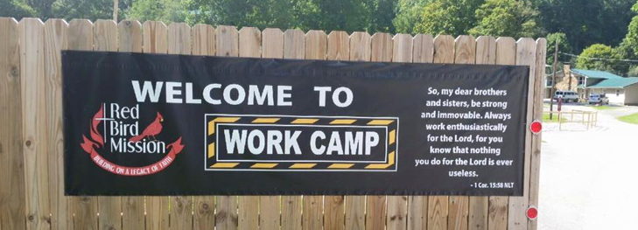

At Red Bird Mission in Appalachia Beverly, Kentucky

Repair houses and do other work in this beautiful area where our brothers and sisters live in great financial poverty

Sun. Aug 11 to Sat. Aug 17, 2019

Cost is $375 (plus your transportation)

We MUST have a $50 non-refundable deposit by Jan 15, 2019

Everyone welcome, especially youth and families!

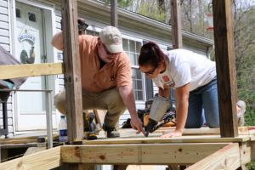

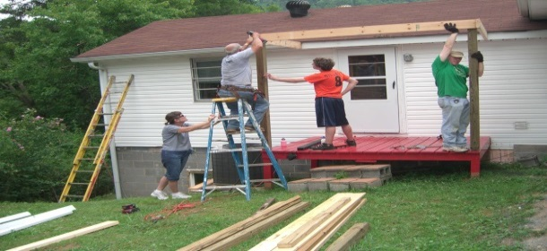

Sponsored by ELM - the Deaf Ministries of the Evangelical Lutheran and

United Methodist Churches

Contact Patti Ravilious at rev.patti.rav@gmail.com or carolstevens100@hotmail.com

By Jan 15, 2019 mail $50 non-refundable deposit payable to Red Bird Mission to Carol Stevens 5303 Christiana Mdws, Bear, DE 19701

