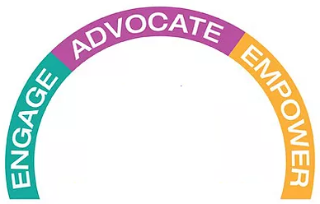
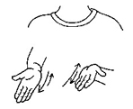
SERVE

SEJ Deaf Ministry Retreat:
Leadership Training
The United Methodist Congress of the Deaf
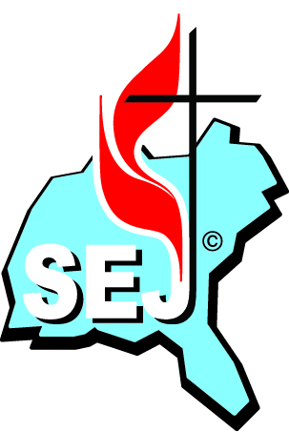

1 Peter 4:10
Each of you should use whatever gift you have received to serve others, as faithful stewards of God's grace in its various forms.
Retreat Schedule
Meals
Presentation
Worship
Meeting
Travel
Host Church: Conway United Methodist Church
3401 S. Conway Rd
Orlando, FL 32812
FriDAY, March 22
9:00am – 12:00pm | Meet at Conway UMC & Depart for  Christ Church at Frederica
12pm – 1pm | Lunch
1pm – 3pm | WESLEYAN TRAINING: Methodist History & Theology  (Tour of Christ Church at Frederica where John & Charles Wesley preached)
3pm – 4pm | Depart Christ Church at Frederica for Epworth by the Sea
4pm – 5pm | Check in at Epworth by the Sea
5pm – 6pm | Dinner
6:15pm – 6:30pm | Evening Devotional
6:30pm – 8:30pm | WESLEYAN TRAINING: Works of Piety / Works of Mercy  (spiritual disciplines / servant leadership)
SatURDAY, March 23
8:00am – 9:00am | Breakfast Meeting
 | (SEJ business meeting)
9:00 – 9:15am | Morning Devotional
9:15am – 12:00pm | WESLYAN TRAINING: Christian Witness  (lecture, tour, & conversations of Epworth Museum)
12:00pm – 12:45pm | Lunch
12:45pm – 1:15pm | Depart to Ft. Frederica (national park)
1:15pm – 3:00pm | WESLYAN TRAINING: Christian Witness  (tour of Ft. Frederica)
3:00pm – 6:00pm | Depart Ft. Frederica to Conway UMC in Orlando
(Schedule is subject to change)
Retreat will be held at
Epworth by the Sea
100 Arthur J Moore Dr
St Simons Island, GA 31522
Welcome Letter
We’d like to personally welcome each of you to the Southeastern Jurisdiction Retreat. It’s an exciting time for this SEJ of the United Methodist Congress of the Deaf (UMCD), as we continue to grow and adapt, remaining always flexible, motivated and responsive to evolving missions and needs towards Deaf, hard of hearing, late-deafened, Deafblind persons and their families. Our caucus is confronting a time of many changes and we’re meeting these changes during a time of larger denominational-wide and global change. The world of Deaf ministry is an exciting area in which to work/study/play, and we hope to continue to meet and bring inspired people together in places like this, to ensure our UMCD and this jurisdiction remains at the cutting edge.
We’d like to give you an idea of what you can expect and what we hope to achieve over the these two days. The retreat theme is “serving.” We are reminded of the words of the Apostle Peter as he wrote to his faith community,
1 Peter 4:10
Each of you should use whatever gift you have received to serve others, as faithful stewards of God's grace in its various forms. (NIV)

With the theme of “serving” in mind, the leadership training offered is
* Wesleyan training (by Rev. Leo Yates, Jr.)
Along with the leadership trainings being offered, we will have time of worship, fellowship, and networking. It’s part of our hope that we are all better connected as the SEJ, as the UMCD, and with other United Methodists across the denomination.
The UMCD continues to meet the challenges we face and to excel despite any setbacks.
Before we close, we’d like to thank each of you for attending this retreat and bringing your passion, faith, and expertise to this retreat. You, as members and participants, have the vision, the knowledge, the faith and the experience to help UMCD pave our way into the future. You are truly our greatest asset today and tomorrow, and we could not accomplish what we do without your support, participation, and leadership. Throughout this retreat, we ask you to stay engaged, keep us proactive and help us shape the future of the SEJ, and UMCD, and its work. Our personal respect and thanks goes out to all of you.
Blessings,
Mary Harris, Associate of the SEJ Deaf Ministries
Pastor Dianne Davis
Rev. Leo Yates, Jr., Deaf & Hard of Hearing Ministries Committee Consultant
Billy Deters, President of the United Methodist Congress of the Deaf
Mary Ann Deters, President of the SEJ Deaf Ministries
Betty Ostrom, Associate of the SEJ Deaf Ministries
Conway United Methodist Church, Host Church
THANK YOU LETTER
General Board of Global Ministries
of The United Methodist Church
458 Ponce De Leon Ave. NE
Atlanta, Georgia 30308
March 22, 2019

Dear Global Ministries,
Immensely Grateful! This is at the heart of what the Southeastern Jurisdiction of the national caucus, United Methodist Congress of the Deaf (UMCD) board and host church planning committee, feels about the generous support from Global Ministries Committee on Deaf and Hard of Hearing Ministries.
On behalf of the host church that planned the retreat, we want to extend a heart-felt thank you for your commitment to making this event happen. Your care, financial support, encouragement, and prayers are the cornerstones of this SEJ Deaf Ministries retreat in Orlando, FL, in which this retreat is being held from March 22-23, 2019. It was the vision of the retreat planning committee to inform, empower, and engage our participants in a pleasant, comfortable environment. Your overall support helped make our vision a reality by helping to offset the cost of holding the retreat in an environment that is inclusive of Deaf, hard of hearing, late-deafened, and Deafblind persons and their families.
As we continue to grow as a caucus that supports all Deaf persons and their families, along with other United Methodist churches, please know that partnerships with our sponsors are vital to the success of this caucus. Global Ministries is truly appreciated. Thanks again.
Sincerely,
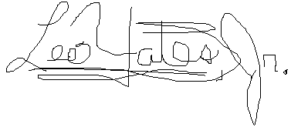
Rev. Leo Yates, Jr.
Planning Retreat Support Staff
443-991-3795
leoyjr@aol.com
On behalf of the Host Church
Mary Harris, church member
Pastor Dianne Davis
TRAINING DESCRIPTIONS

WESLEYAN TRAINING
METHODIST HISTORY & THEOLOGY – This presentation includes a history and theology of Methodism (The United Methodist Church). A study of John Wesley, the father of Methodism, will provide participants the rich history of the United Methodist denomination. This two hour presentation will be taught by Rev. Leo Yates, Jr. and Mary Harris. The training is on Friday, March 22, 2019.
WORKS OF PIETY - John Wesley is the father of Methodism. The Wesleyan training focuses on Wesley’s Works of Piety and Works of Mercy concepts. The Works of Piety presentation focuses on spiritual development that helps participants to stay better connected with God, be spiritually nurtured and provide a stronger foundation of faith. This two hour presentation will be taught by Rev. Leo Yates, Jr. The training is Friday, March 22, 2019.
WORKS OF MERCY – Another important Wesleyan concept is Works of Mercy. A strong emphasis of this is serving God by serving others and one of the best ways to do so is to be familiar with your spiritual gifts. Included in the presentation are: A spiritual gifts inventory, ideas of ways to serve, and where to serve. This is a two hour training. This presentation will be taught by Rev. Leo Yates, Jr. The training is Friday, March 22, 2019.
CHRISTIAN WITNESS – An emphasis of United Methodist theology is Christian witness. We see Christian witness as a mission and evangelistic (sharing our faith) where we have opportunities throughout our lives to witness (show) our Christian faith to others. During the retreat, we will go on two field trips where we will be able to provide Christian witness and share the hope we have based on our faith. This will be on Saturday, March 23, 2019.

The History of the United Methodist Congress of the Deaf
The following are snippets from the manual, The History of the United Methodist Congress of the Deaf. The United Methodist Congress of the Deaf (UMCD) is an approved national caucus of The United Methodist Church. One meaning of caucus is a group within an organization or political party which meets independently to discuss strategy or tactics. Included in the manual is the history of the Deaf missions and Deaf churches, their works, challenges, and blessings that led up to the beginnings of establishing UMCD. The history was written and compiled by Rev. Dr. Kirk VanGilder.
The manual begins with the history of the work of Thomas Gallaudet and his pursuit of Deaf education in America. As Deaf students graduated from residential Deaf schools, where they had Deaf community, their desire to remain in community with one another was still desired and needed. The first denomination that implemented a Deaf ministry, a Deaf congregation, was The Protestant Episcopal Church, which was led, in part, by the efforts of Thomas Gallaudet (the oldest son of THE Thomas Gallaudet who helped establish the first Deaf school in America). It then shifts to the first known Methodist Deaf ministry began by Philip J. Hasenstab in Chicago, IL. Hasenstab’s entry into ministry happened, somewhat, by chance when the traveling preacher visiting requested assistance. Hasenstab began helped and preached during the summer of1890, which then led to receiving an exhorter’s license (similar to a preacher’s license) by Grace Episcopal Methodist Church on April 17, 1890. Hasenstab received financial support and was appointed as the first Deaf preacher on September 15, 1893 for the Chicago Mission of the Deaf. Part of Hasenstab’s work was providing religious education and worship at the Deaf school. Following this in the manual is the historical account of Rev. Daniel E. Moylan who pastored the Eutaw Street Methodist Episcopal Mission for the Deaf in Baltimore, MD. Moylan was granted a license to preach in 1895 when Moylan asked a District Superintendent on December 24th. The subsequent historical accounts included other Deaf ministries and Deaf congregations in our United Methodist Deaf history that led up to UMCD.
The following are continued snippets from the original manual by VanGilder as it relates specifically to UMCD.
