
Highlights of the Weekend
- Gathering Friday evening at 7pm, adjourning Sunday at noon
- Beautiful Lake Junaluska and shopping in the quaint town of Waynesville
- Seeing friends from all across the nation
- Great worship with Bishop Peggy Johnson
- Saturday night Celebration Banquet
of past leaders of WNCC Deaf
Ministry

- Bible Study
- Meet Marshall Lawrence and
‘Dr. Wonder’

Rev. Tom Summey was received back from the military where he had served as a Chaplain during the Vietnam Conflict and the Korean War by Bishop Earl Hunt in the late 1960s. He served a large United Methodist Church in Greensboro until his hearing loss, due to excessive loud gunshot fire, took his ability to serve his congregants effectively.

Bishop Hunt met with Rev. Summey in 1970 and proposed that he return to school at Lenoir Rhyne College, learn sign language, and create a form of Deaf Ministry.

In 1971 Deaf Ministry was born in the North Carolina Mountains thanks to the vision of Bishop Hunt and the willingness of Rev. Summey.

Over the past 40 years the little ministry has come down off the mountain under the leadership of various devoted hearts to Jesus that have a passion for the deaf and hh in Western NC.

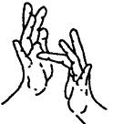
Ministries with Deaf,
Late-Deafened,
Hard of Hearing and
Deaf-Blind
CELEBRATING
40 years of Deaf Ministry
in
The Western N.C. Conference of the
United Methodist Church
July 29th-31st, 2011

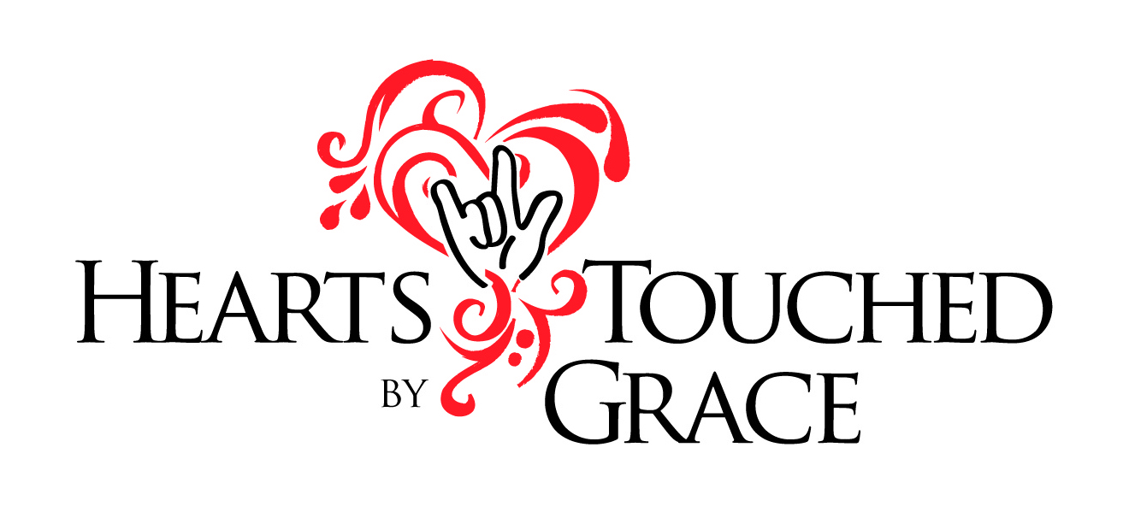
Western NC UMC Deaf Ministry Origins:
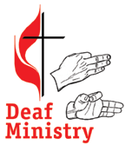

United Methodist
Congress of the Deaf
Founded in 1973 by a network of ministers and Deaf people within the United Methodist Church, UMCD’s purpose is to "celebrate and promote Christian leadership and discipleship within the Deaf community.” In 2005, UMCD hosted the first Global Deaf Methodist Missions Conference in Baltimore, Maryland, welcoming people from Korea, Japan, Guam, The Philippines, Kenya, Sri Lanka, and Liberia. UMCD is pleased to be part of celebrating 40 years of Deaf Ministry in Western North Carolina. We pray for more United Methodist churches to reach out and invite Deaf people to the ministry of Jesus Christ.

Keynote Speaker
Bishop Peggy Johnson
Of
The Philadelphia Area

We are excited to welcome Bishop Peggy A. Johnson, ‘Rev Pink’, to the ‘Hearts Touched by Grace’ celebration. Her history includes a four-point country charge in Frederick MD, as campus minister for Gallaudet University, and as co-pastor (with her husband, Mike) of Lansdowne United Methodist Church, in Baltimore, MD. She also served for 20 years as pastor of the historic Christ UMC of the Deaf in Baltimore starting in 1988.
Bishop Johnson has a heart for persons with disabilities and believes strongly in their inclusion as co-ministers in the priesthood of all believers. “Often we think we’re going to help people with disabilities – but no – they help us see things with wonderful new perspective and add to the giftedness of the Body of Christ. Without them we’re not fully complete; we need their gifts for being the fully functional Body of Christ”
She believes that the most important role as a bishop is to pastorally empower and encourage the church to make Disciples of Jesus Christ for the transformation of the world.

Accommodations
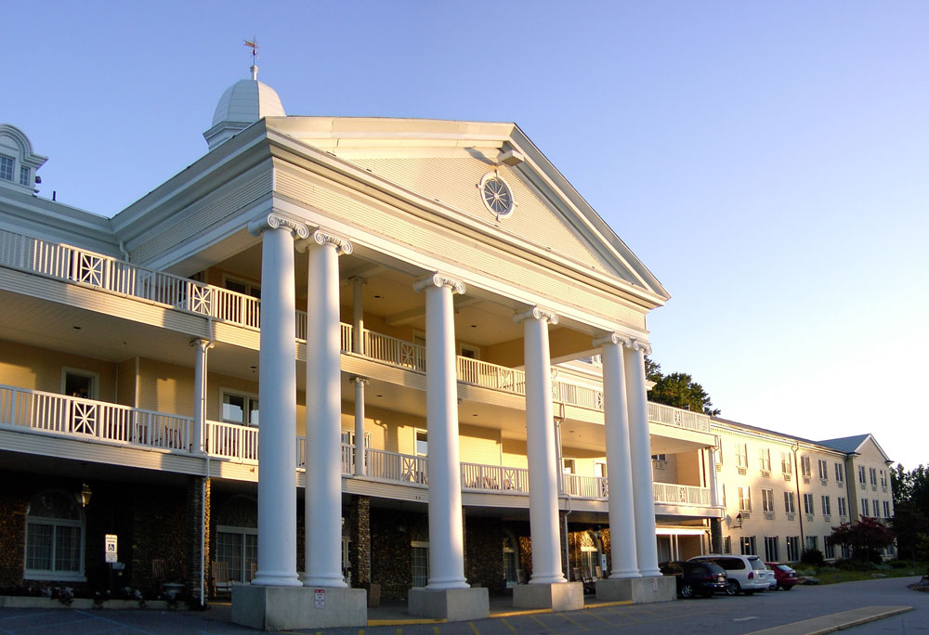

Lambuth Inn

689 North Lakeshore Drive,
Lake Junaluska, NC 28745

Rooms are furnished with flat screen TVs, telephone, private baths, and wireless internet access. Handicap accessible rooms are available.

Rates:
Single | Double | Triple | Quad
$104 | $58 | $40 | $33

Meal Plans:
Brkfast | Lunch | Dinner | 3meal pkg
$8.95 | $10.95 | $13.00 | $28.85

MAKE YOUR RESERVATION NOW
TO INSURE YOURSELF A ROOM!!!

www.lakejunaluska.com/lambuth-inn/

Event code # 28810105331

SEE YOU AT THE LAKE!

