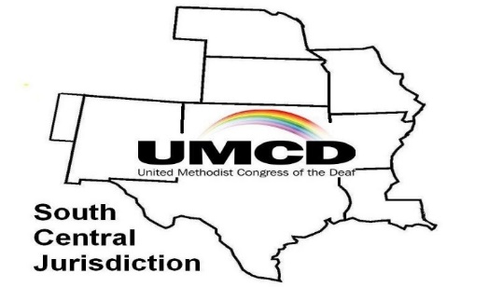

July 29 – 31, 2019
SCJ-UMCD Conference Registration Form

Please complete the following information.
Return the form with registration fee and send to:

FUMC Deaf and HOH Ministry
1016 Sam Houston Ave
Huntsville, TX 77320

First Name _________________________________________
Last Name _________________________________________
Email Address __________________________________________
Home Church/City __________________________________________

Do You need voice interpretation? (circle one) Yes No
Do you need ASL interpretation? (circle one) Yes No
Do you need assistive listening device? (circle one) Yes No

Special Dietary concerns__________________________________

Early Bird Registration before May 20, 2019: $150
Registration after May 20, 2019: $175
Package deal: Includes three meals, snacks, tote bag, workshops, and if needed transportation from the hotel to FUMC church.

Optional: Please circle the following items to include in your registration:
SCJ-UMCD Membership (2 Years) $20
Student SCJ-UMCD Membership (2 years) $10
SCJ-UMCD Membership (1 year) $10

Conference T-Shirt: $12 Each (XXL $15 each). June 17th, the last day to order.

Circle the correct Adult size:
Small Medium Large X-Large XX Large

Conference Registration $__________________________
Optional:
SCJ-UMCD Membership $__________________________
Conference T-Shirt $__________________________
Total Registration Fee $__________________________

Your registration fee does not include hotel fee. See the next page for additional hotels information with their group code discount rate.
For more information contact:
SCJ-UMCD President - Michelle Martin at michelle.martin@yahoo.com
FUMC Liaison - Leslie Michaelson at leselaine@sbcglobal.net

Send Registration form and check payable to “FUMC Deaf and HOH”
(Please add “SCJ-UMCD Conference” on memo line)

Send to: FUMC Deaf and HOH Ministry
1016 Sam Houston Ave
Huntsville, TX 77320

Your Registration Fee Does Not Include Hotel fee.

Hotels Information:

Holiday Inn Express & Suites Huntsville
148 Interstate 45 S
Huntsville Texas 77340
Phone: 936-295-4300

To make a reservation please request the group discount rate for UMCD CONFERENCE

Holiday Inn Express & Suites Huntsville website:
https://www.ihg.com/holidayinnexpress/hotels/us/en/huntsville/hvles/hoteldetail/hotel-packages#scmisc=nav_hotel-packages_ex

Rooms are available on Friday and Saturday at $109 per night plus tax.
Must make the reservations by June 20, 2019 at this rate.

Rate includes:
Complimentary Deluxe Hot Breakfast daily
Complimentary Wired or Wireless high-speed in-room internet connectivity
Complimentary access to the hotel Fitness center
Complimentary access to the Indoor Pool and Jacuzzi.

Days Inn & Suites Days Inn by Wyndham Huntsville
160 IH-45 South
Huntsville, TX 77340
936-438-8400

To make a reservation, you must call (cannot make reservation online) and request the group discount rate for FUMC.

Rooms are available on Friday and Saturday for Single King for $75.99 per night plus tax or Double Queen for &79.99 per night plus tax. Must make the reservations by June 20, 2019 at this rate.

Rate includes:
Complimentary continental breakfast daily
Complimentary wireless Internet access
Complimentary outdoor pool.

