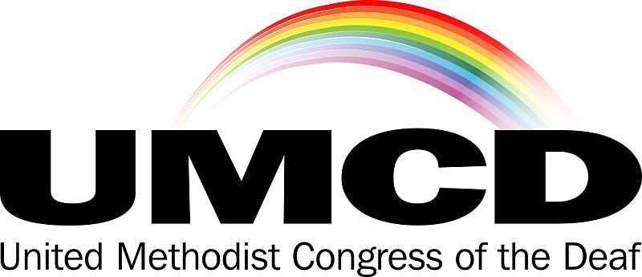

October 13, 2022

The United Methodist Congress of the Deaf was established in 1978 as an independent caucus of Deaf and Hard of Hearing people and hearing people involved in ministry with our populations in The United Methodist Church. Our caucus was formed out of a desire to equip UMC congregations with an understanding of Deaf culture and monitor and advocate for accessibility and inclusion for Deaf and Hard of Hearing people throughout the connection.

On behalf of the board of the UMCD, we write to affirm the nomination of Rev. Dr. Sunny Ahn for the Episcopacy in The United Methodist Church. Rev. Dr. Ahn has been an advocate for access and inclusion at Kona UMC in Kailua-Kona, HI. In her tenure as Senior Pastor, she has facilitated the establishment of worship services made accessible through American Sign Language (ASL) interpretation and empowered her congregation to better welcome and include Deaf people through arranging for ASL classes. In addition to her work at Kona UMC, Rev. Dr. Ahn networked and ministered with the Deaf community on the Big Island of Hawai’i.
In her correspondence with us, Rev. Dr. Ahn has expressed a desire to use her candidacy and potential Episcopacy to carry forward more awareness of Deaf and Hard of Hearing people throughout the denomination. We have enjoyed such a partnership with Bishop Peggy Johnson for a number of years but with her recent retirement, the Deaf and Hard of Hearing members and ministries of the UMC once again enter a time when we are uncertain of whether active Bishops are aware of our communities and engaged in our ministries. Thus we are delighted to affirm the candidacy of Rev. Dr. Sunny Ahn for the office of Bishop.

Sincerely,

William M. Deters, President

United Methodist Congress of the Deaf
www.umcd.org
℅ United Methodist Committee on Deaf and Hard of Hearing Ministries
General Board of Global Ministries
458 Ponce de Leon Avenue NE, Building A, Suite 1
Atlanta, Georgia 30308

