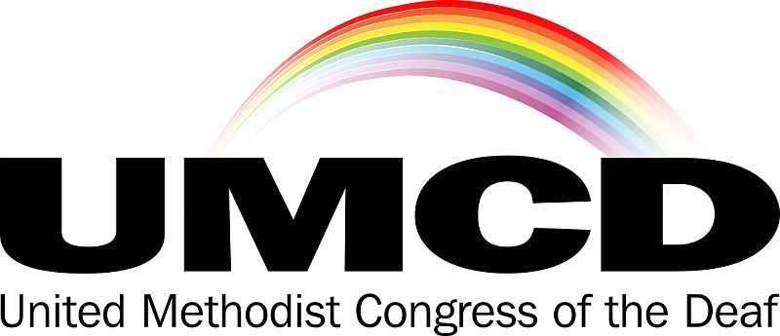

October 13, 2022

The United Methodist Congress of the Deaf was established in 1978 as an independent caucus of Deaf and Hard of Hearing people and hearing people involved in ministry with our populations in The United Methodist Church. Our caucus was formed out of a desire to equip UMC congregations with an understanding of Deaf culture and monitor and advocate for accessibility and inclusion for Deaf and Hard of Hearing people throughout the connection.

On behalf of the board of the UMCD, we write to affirm the nomination of Rev. Dr. Giovanni Arroyo for the Episcopacy in The United Methodist Church. Rev. Dr. Arroyo’s work as the General Secretary of The United Methodist Church’s General Commission on Religion and Race (GCORR) has included close collaboration with the Disability Ministries Committee of the UMC and the United Methodist Committee on Deaf and Hard of Hearing Ministries. He completed a course on Deaf Ministry at Wesley Theological Seminary in Washington, D.C. taught by Bishop Peggy Johnson. Also, his leadership with the GCORR has overseen grants for multicultural ministries that include a recognition of ministries at the intersection of Deaf culture and racial and ethnic minorities.

Rev. Dr. Arroyo's experience and awareness of Deaf culture and the unique nature of our ministries as a linguistic and cultural minority is encouraging. We have enjoyed the presence of such awareness in the Episcopacy with Bishop Peggy Johnson for a number of years but with her recent retirement, the Deaf and Hard of Hearing members and ministries of the UMC once again enter a time when we are uncertain of whether active Bishops are aware of our communities and engaged in our ministries. Thus we are delighted to affirm the candidacy of Rev. Dr. Giovanni Arroyo for the office of Bishop.

Sincerely,

William M. Deters, President

United Methodist Congress of the Deaf
www.umcd.org
℅ United Methodist Committee on Deaf and Hard of Hearing Ministries
General Board of Global Ministries
458 Ponce de Leon Avenue NE, Building A, Suite 1
Atlanta, Georgia 30308

