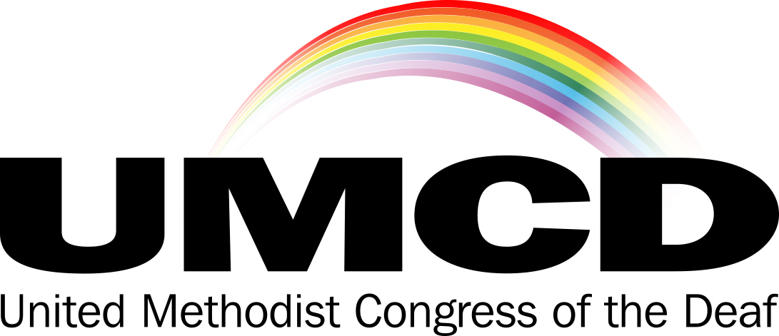
UMCD Membership and Endowment Fund
Please enter your membership using the form below. Also, UMCD established an Endowment Fund in 1999 to encourage local churches to develop new ministries with those who are Deaf, Hard of Hearing, Late Deafened or Deaf-Blind. Donations to UMCD and/or the Endowment Fund are tax deductible.
DATE: _____________________________
Name: (First name) _________________________________________
(Last name) _________________________________________
Address: ____________________________________________
____________________________________________
State: ______ Zip Code: ______________
Telephone: _______________________ Voice/TTY/VP (Circle which applicable)
Text/cell: _____________________
Email: _________________________________________
Your church home: _______________________________________________________
$ _________ UMCD Dues ($10.00 per year or $20 for 2 years)
$ _________ Donation to Endowment Fund
$ _________ Donation to UMCD
$ _________ Total Enclosed
Make your check payable to “UMCD”, memo “Membership” and/or “Endowment Fund”
Mail To: Linda Ford, UMCD Treasurer, 7405 S Granite Ave., Tulsa, OK 74136
Thank you for supporting the United Methodist Congress of the Deaf.

