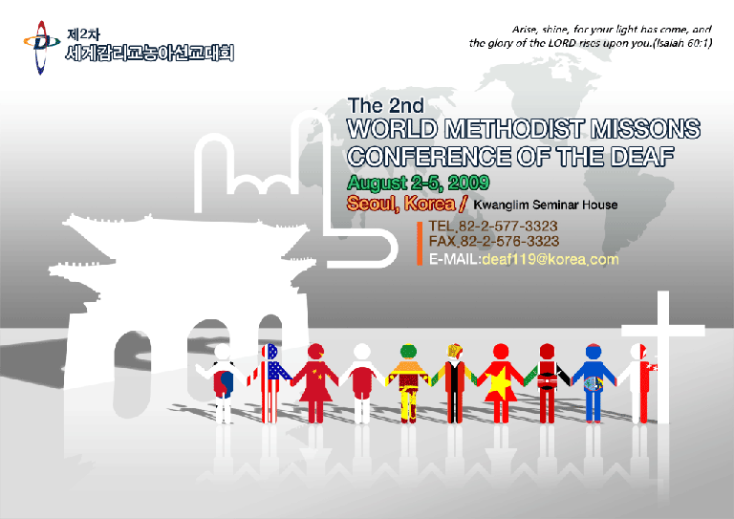

2009 UMCD Global Conference in Seoul, Korea

Twenty–five UMCD members from the US and two from Kenya will be attending the 2009 UMCD Global Gathering/2nd Global Gathering of Deaf Methodists in Seoul, South Korea. They will arrive on Thursday, July 30, 2009, go on a tour to various places (see last fall’s UMCD Newsletter for details) on July 31 and August 1 and morning of August 2, 2009. UMCD Global conference begins in the afternoon of August 2 and lasting until noon, Wednesday, August 5. More than 500 people are expected to attend this conference – from Korea, Japan, Guam, Singapore, Sri Lanka, and other countries. The UMCD gathering will be different. There will be 3 days of testimonials, devotions, worship and Bible study. This should be an inspirational experience, something to take back home to share with others!
Signs of Change

The United Methodist

Congress of the Deaf

Newsletter

Greetings from Spring 2009
Dan Kenyon

UMCD President’s Report

Hi Everyone! I hope you all had a wonderful Easter. Remember to celebrate Jesus Christ each and every day, through your prayers and your service. I have several news items that I want to share with you.

Election of UMCD Executive Officers

In August of this year UMCD will have an election of Officers – President, Vice-President, Secretary, and Treasurer. For the first time, the UMCD election of executive officers will be done by postal mail. If you have someone in mind who you would like to serve as an officer for the position(s) above, please contact and inform your Jurisdiction President (JP). Your JP also serves on the Nominating Committee. The JP names and email address can be found near the end of this newsletter. Only those who have paid their dues will receive a ballot through postal mail. If you have not paid your dues since our 2007 UMCD meeting in Orlando, FL, please complete the UMCD Membership and Endowment Fund form on the last page of this newsletter and send in your membership due payment to our treasurer, Rev. Tom Hudspeth. Remember - Your membership needs to be current before you can vote. Thank you.

New Western Jurisdiction President

Rev. Diana Williams is the new Western Jurisdiction President. She replaced Candis Shannon who has faithfully served this position the past 4 years. Diana is a pastor of St. Matthews UMC in Mesa, AZ which has a strong Deaf ministry there. She was also recently elected to UMCom (United Methodist Committee on Ministries with Deaf, Late-Deafened, Hard of Hearing, and Deaf-Blind People) Board. Also, Paul Spears was elected WJ Vice President and Michelle Beaudry was elected as Secretary-Treasurer. Please welcome Diana, Paul, and Michelle to UMCD. BIG thank you, Candis!
2009 UMCD Global Conference in Seoul, Korea

Twenty–five UMCD members from the US and two from Kenya will be attending the 2009 UMCD Global Gathering/2nd Global Gathering of Deaf Methodists in Seoul, South Korea. They will arrive on Thursday, July 30, 2009, go on a tour to various places (see last fall’s UMCD Newsletter for details) on July 31 and August 1 and morning of August 2, 2009. UMCD Global conference begins in the afternoon of August 2 and lasting until noon, Wednesday, August 5. More than 500 people are expected to attend this conference – from Korea, Japan, Guam, Singapore, Sri Lanka, and other countries. Our UMCD gathering will be different. There will be 3 days of testimonials, devotions, worship and Bible study. I believe that this will be an inspirational experience, something for us to take back home to share with others!

Have You Sign Up with UMCD’s Group Email Service?

We will have discussions on these issues through our UMCD@yahoogroups.com. If you haven’t yet sign up to our UMCD group email, please email your request, along with your email address, to Rev. Rick Springer at umc.deaf.ministry@sbcglobal.net if you wish to be added to this UMCD group email list. Don’t be left out!

You are welcome to join UMCD or renew your membership or to make a donation. Please complete the form at the end of the newsletter and send your dues and/or donations to our treasurer, Rev. Tom Hudspeth. Thank you!

This issue only has news from the NEJ, SCJ, and WJ. If you have news concerning your church, your annual conference, past events, coming events, pictures, etc., please share them with UMCD members and send your news items at dmj730@comcast.net for our next UMCD Newsletter. We want to hear from you!. Thank you.

Lastly, please pray for all of us who will be attending the 2009 UMCD Global Gathering in Seoul, S. Korea for our presence there and for our safety.

Blessings and Peace,

Dan Kenyon

Ordination of Rev. Elke Sharma

Rev. Elke Sharma will be ordained in the Oregon-Idaho Annual Conference on June 13th. Elke was first commissioned, and then went through 3 years of probation. Now she is finally ready to be ordained an Elder. This is the new way we do this in the UMC. (In the old days there was ordination as Deacon and then a second ordination to Elder – now we only ordain once. The first step is called commissioning, and it is a time to see if a person will really work out before they are ordained and guaranteed an appointment for life.

Rev. Elke has been serving the Deaf Faith Community in Jacksonville, IL within the Illinois Great Rivers Conference. She was recently elected Secretary of the United Methodist Committee for Ministries with Deaf, Late-deafened, Hard of Hearing and Deaf-blind People (UMCom) (see below). She is married to Aditya Sharma, and they have a son named Ashwin. Elke's mother, Carol Carter, is an ordained UM Clergy from California Nevada Annual Conference.
A New “National” Committee Meets

The United Methodist Committee for Ministries with Deaf, Late-deafened, Hard of Hearing and Deaf-blind People (UMCom) met February 13-15, 2009, at Lovers Lane UMC in Dallas Texas. Since we work globally, we have dropped the word “national” from our description.

For the next four years, the members of the committee will be focusing on programs with our four ministry groups, resources for all age levels with a focus on children and youth, recruiting and training deaf lay ministers for deaf, Deaf congregations, and models for ministry with persons who are late-deafened, and hard of hearing, especially older adults. We also heard a report of an invitation to mission in Armenia. If you care interested in helping to train the deaf in Yerevan, Armenia, please contact Wineva @ ilycul@yahoo.com or mnercess@yahoo.com. Marina Nercessian is the leader of this project that will work through Volunteers in Mission.
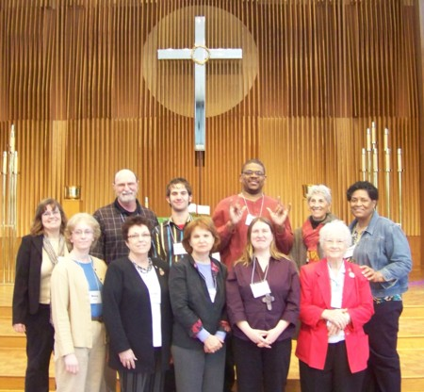

The new committee members are as follows:

President: Michelle Martin
Vice-president: Sam Carpenter
Secretary: Elke Sharma
Grants Subcommittee: Nancy Hale

Members: William Suggs, Rebecca Kelly, Diana Williams, Barbara Reynolds, Trevor Swearingen, and Jeff Burns.

The Lovers Lane Deaf Ministry’s Cross, Heart, Hands Class commissioned the new committee members, standing in front of a beautiful new altar that was crafted by one of our new members, young adult Trevor Swearingen, as his Eagle Scout project.

Visit our website, www.umcsignsofsolidarity.org to see the new members. We also have a blog where you can view pictures of our recent meeting. We are able to offer limited grants and scholarships for projects and education, so please check on our website to see if your project qualifies.

UMCom is excited about the future of ministries with Deaf, Late-deafened, Hard of Hearing and Deaf-blind people. We hope you will be in touch with us!

Wineva Hankamer, Consultant to the Committee
5629 Kingwood Drive, Kingwood, TX 77345.
Phone No. 281-360-4500 x 107 Anytime Cell 713 315-7593

Deaf-Blind Camp of Maryland

Deaf-Blind Camp of Maryland started over 10 years ago at Camp Manidokan by Bishop Peggy Johnson to provide a safe, fun, barrier-free week for persons with dual disabilities of hearing and vision loss. It has grown from 6 campers to 40 campers annually. Due to increase in the number of campers, and needing more accessibility, the camp was relocated to West River United Methodist Camp in Churchton, Maryland.

The camp will be held at West River this coming June 7 – 12, 2009. There are many outdoor recreational activities, indoor activities, worship services, field trips, and many other services.

Everyone involved in the camp is a volunteer, including the planning committee, coordinators, and the SSPs (Support Service Providers). One of the campers last year commented, “I felt happy inside to feel God in the hands of my SSPs”.

The camp is very expensive to operate, and if any would like to make a donation, please send checks to

Deaf Interfaith
911 Regina Drive
Baltimore, Md. 21227

Thank you.

Toby Witte-Dix
Coordinator and Treasurer

Deaf Shalom Zone, Inc. - Greetings!

The Deaf Shalom Zone, Inc. is a faith based organization that facilitates empowerment and independence opportunities with the culturally Deaf and Deaf/Blind in the community of metropolitan Baltimore. It is located at Christ United Methodist Church of the Deaf in Baltimore, Maryland. The Zone provides case management, culturally appropriate programming and advocacy. The Deaf Shalom Zone, Inc. builds relationships with the culturally Deaf and Deaf/Blind, their family members, service providers and volunteers, assists in meeting their basic human needs, and encourages them to identify their gifts for service to others in the community. Some examples of culturally appropriate programs are Deaf Tax Day, Deaf Parenting Classes, Deaf computer classes, and so much more.
Two recent successes at the Deaf Shalom Zone are:
- Through the DSZ Food Pantry we have been able to pass out approximately 67 packages of free eggs, milk, fresh veggies, and meat over the past four months.
- Deaf Tax Day served 81 individuals and raised over $400.
The Deaf Shalom Zone, Inc. is always looking for committed volunteers. If you would like to help out or find out more about the services offered please visit our website at www.deafshalomzone.org or send us an email at volunteeropportunities@deafshalomzone.org

Blessings of Shalom,

Mary B. Gladstone, Coordinator
Deaf Shalom Zone, Inc.

Deaf Shalom Zone Needs Funds

By Mary Jane Kenyon

Deaf Shalom Zone (DSZ) needs funds in order to serve its clients. Mary Gladstone and I discussed fund-raising ideas.

I have knitted and crocheted blankets, hats, mittens, scarves for DSZ. I am also teaching a knitting and crochet class at Christ UMC of the Deaf to help make items for donations.

If you would like to donate, please send your check to:

Deaf Shalom Zone
c/o Christ UMC of the Deaf
1040 S. Beechfield Avenue
Baltimore, MD 21229

Any financial contributions are welcome! Thank you!

The Mark of the Cross
By Rev. Leo Yates, Jr.

As we celebrate each Sunday during the season of Easter, we can stand at the tomb and see where Jesus once laid is empty. It is the place where death lost and life in Christ won. Each Sunday, we are reminded that the Lord has risen because we worship a risen Lord, thus making our faith communities resurrected with Christ. Each of us as individuals is a part of our faith communities, thus making each one of us part of the resurrection. Our hope is in Christ. Romans 8:31 tells us What, then, shall we say in response to this? If God is for us, who can be against us? Being risen with Christ, it sets us apart in grace.

On the flip side, we have a God who walks with us and talks with us, even when the journey is hard. For Christ walked that journey too. The suffering Jesus experienced is our suffering, making our suffering his as well. The Jews during the Holocaust were tattooed because the tattoos identified them to the Nazis. For us as Christians, our spirits are spiritually marked by the cross. This identifies us as having died and being raised with Christ. Having been marked by the cross ensures us that it’s God’s grace we need.

The cup of suffering (the hard times) talked about in the garden by Jesus reminds us of what the Psalmist wrote in Psalm 23:5, “my cup overflows.” The blessing to us by God, through the crucifixion and the resurrection of Christ, shouldn’t be underestimated, but ought to be embraced with gratefulness and worship. Our hope is ensured (it will happen). Let us worship and celebrate, not only the Sundays during the Easter season, but all Sundays, with thanksgiving. For Christ has risen, indeed.

Smile! God Loves You!

News from Magothy UMC of the Deaf

By Darlene Koontz, NEJ President

Magothy United Methodist Church of the Deaf (MUMCD), Pasadena, MD hosted a one day NEJ Conference in May 17, 2008. There were many positive comments from the people who attended. There were four workshops offered:
· “How to deal with Grief and Loss” by Liz Katz, LCSW
· “Empowering Laity to Visit the Sick” by Rev. Leo Yates, Jr.
· “Chronological Bible Study” by Rev. Chris Hughes
· “Spiritual Growth” by Rev Rick McClain.
Rev. Rick gave an inspiring message about “Five Essonite Factors of Spiritual Formation.” Spiritual Formation Factors are PRAYER LIFE, DEVOTIONAL LIFE, SCRIPTURE LIFE, EVEANGELISTIC LIFE, and EVERYDAY LIFE. He emphasized his statement of “If you are weak in your Christian walk, it is because you are weak in one of these areas.” My niece, Jamie shared with people her experience after her father passed away a few days before the conference. I feel that God had planned the grief & loss workshop, for some people needed to learn and understand this subject. There were approximately fifty people in attendance, a few traveled from as far as Delaware, NJ as well PA. NEJ Vice President, David Ennis, said that the 2008 NEJ conference was much more successful than any past NEJ Conferences because the planners kept the workshops Christ-centered. Debra Fry from Delaware offered to host her church for NEJ Conference in 2010.
We had another successful year as a church with much of the church’s focus being on missions and outreach. I commend the mission’s committee and other contributors for their hard work.
In summary, for 2008, a few of the missions that were sponsored by the church are
· Deaf Blind Camp
· Deaf Children’s Camp
· Deaf Adults Cam
· Global Ministry
· Adopt-A-Family (AACo Dept of Social Services)
· USO Kaiserslautern (Lundstal hospital, Germany) calling cards for injured soldiers
· Door Step Mission (pantry food for needy families(all round year)
· Anne Arundel County Schools (school supplies
· Harmony House (AACo D.S.S.)
What an accomplishment!! We pray and hope that 2009 will bring just as much fruitful works as 2008 and that our committee members continue to serve in the name of our Lord. Magothy thanks Sarah Yates for her faithful and committed work for 3 years. Nina Gilbert is our new missions chairperson.
Several things have changed since July 2008. Magothy & Christ Church of the Deaf were thrilled when Rev. Peggy Johnson was consecrated Bishop and became the Episcopal leader of another the other annual conference. Our former pastor, Rev Leo
Yates Jr., replaced Bishop Johnson at Christ Church of the Deaf. We thank her for her commitment to Deaf and Blind people.
On Jan 10th, our popular “Soup Fest and Flea Market” began for 2009. These events are held in January, February and March. To our delight and pleasure, the events have become popular and part of our church tradition. It is our fourth year. They are about 8-10 different homemade soups including tossed salad, assorted breads, and crackers. The proceeds from soup fundraisers support different missions like nets for Africa, the building material for an orphanage in China, and help to sponsor a family’s UMCD trip in July 2009. In addition, the sale of hotdogs, drinks, sweets and the rented table for flea market support the on-going mission of our United Methodist Women’s group. Thanks to those who worked very hard and made these successful. What also is important to these fundraisers is the fellowship and community that it creates for those visiting.
As many people know, our former pastor, Rev Joo Kang resigned as pastor due to his ailing mother in Korea. She is 79 years old. We respect his wish to be with his mother. Serving as an interim pastor is Rev. Leo Yates Jr. We are praying that a part time pastor will be appointed soon to our church.
In order to do further outreach to our community, the church is involved in a food pantry and assist with an annual homeless program (April 2009). By extending our efforts to those in need, we feel we bring the love of Christ. Much of our efforts are through one-on-one interaction, which extends a personal hand to those who are struggling and challenged due to our current economy. Matthew 25:35
Obituary - Elizabeth "Forrest Ann" Daniel April 14, 1937 - May 13, 2009
Elizabeth "Forrest Ann" Daniel, former Lay Volunteer in Ministry died on May 13, 2009. Forrest Ann served the Pacific Northwest Conference as a Lay Volunteer in Ministry (LIMPOP) at Pe Ell United Methodist Church, Pe Ell, WA, from
2004 until 2007. She was a long-time member of the McCleary UMC. Funeral Services was held on Saturday, May 16, 2009 at Whiteside Family Mortuary in Elma, WA. Forrest Ann was also a member and officer of WJ UMCD. She did much for the organization, and was our major fundraiser for many years with her skill at writing grants. We will miss her.....
Submitted by Rev. Bob Walker and Candis Shannon

Smile! God Loves You!
Executive Officers

President: Dan Kenyon
dmj730@comcast.net

Vice-President: Rev. Joo Kang
lordseakang@hotmail.com

Secretary: Pat Lancet
pklancet@yahoo.com

Treasurer: Rev. Tom Hudspeth
thudspeth@llumc.org

Jurisdiction Presidents

NCJ Vice-President: Rev. Elke Sharma
pastorelke@yahoo.com

NEJ President: Darlene Koontz
koontz9@comcast.net

SCJ President: Karen Harrell
kiharrell76@aol.com

SEJ President: Toni Parrish
THPDeaf@aol.com

WJ President: Rev. Diana Williams
native.signer.pastor@cox.net

Int’l. Conf. President: Vacant

Committee Chairs

Archives and History - Francine Kenyon
fmkyn@yahoo.com

Church Promotion Deaf Ministries - Karen Harrell
kiharrell76@aol.com

Church Promotion of Late-Deafened
and Hard of Hearing - Rev. Elke Sharma
pastorelke@yahoo.com

Communications Technology - Rev. Rick Springer
UMC.Deaf.Ministry@sbcglobal.net

Interpreter Committee - Michelle Menefee
mlmenefee@sbcglobal.net

Membership Roster - Rev. Bob Vaughn
rvaughn@infionline.net

Youth Ministry - Carmela Kenyon
wwecrazydiva@gmail.com

Other Officers

Past President: Candis Shannon
fireweedccs@yahoo.com

Newsletter Editor: MaryJane Kenyon
dmj730@comcast.net

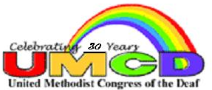
UMCD Membership and Endowment Fund
UMCD established the Endowment Fund for the purpose of encouraging local
churches to develop new ministries with those who are Deaf, Hard of Hearing,
Late Deafened or Deaf-Blind. Your donation to the Endowment is a sign of support and challenge to United Methodists. If you did not attend the 2007 UMCD conference and want to renew your membership or if you want to join UMCD, you may use the form below. Please send your tax-deductible UMCD Membership and/or Endowment Fund donation to the address below. Many thanks!!

Help the Endowment Fund Grow!
_______________________________________________________________________
UMCD Membership and Donations

Name: ______________________________________________

Address: ____________________________________________

______________________________________________________

Telephone: ________________________ Voice/TTY (Circle which applicable)

Email: _________________________________________

$ _________ UMCD Dues ($10.00 per year or $20 for 2 years)
$ _________ Donation to Endowment Fund
$ _________ Donation for _________________
$ _________ Total Enclosed

Make your check payable to UMCD, memo “Membership” and/or “Endowment Fund”

Mail To:
Tom Hudspeth, Treasurer
Lovers Lane UMC
9200 Inwood Rd.
Dallas, Texas 75220

Thank you for supporting the United Methodist Congress of the Deaf.

