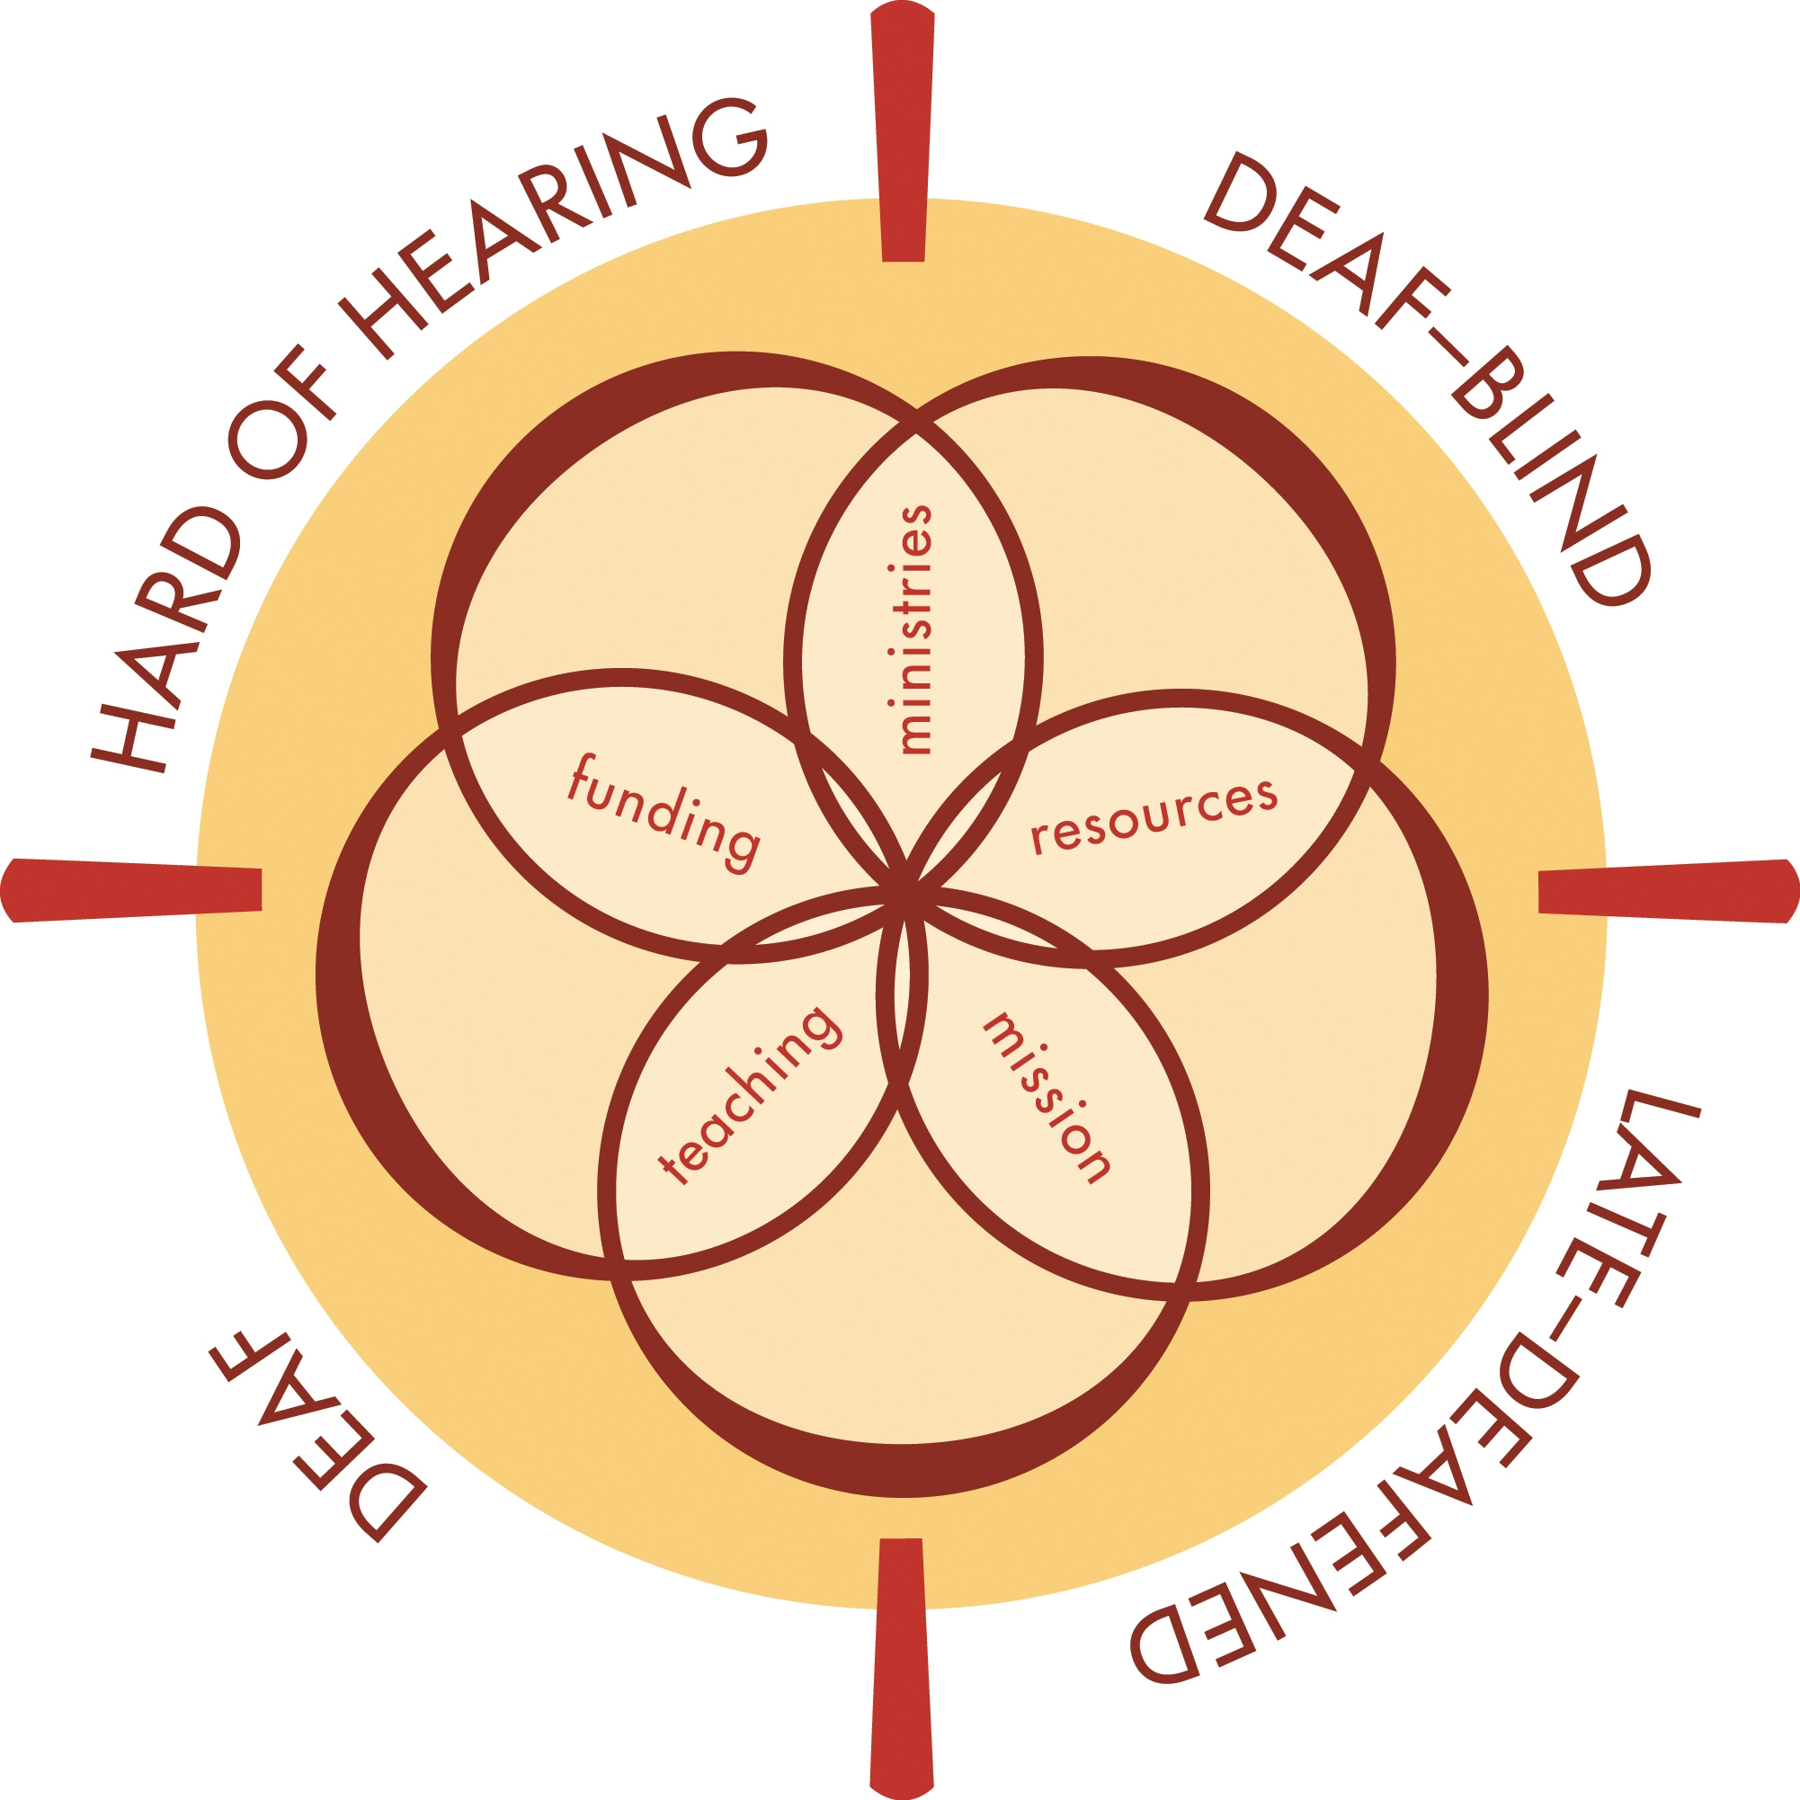

Guidelines for the
“Mardy” Walker Memorial Assistive Listening System

HISTORY

The Assistive Listening System (ALS) was purchased in 2004 through memorial monies placed in an Advance account of the General Board of Global Ministries (GBGM) for the United Methodist Church. The funds honored Marjorie Gamon “Mardy” Walker, spouse of the Rev. Dr. Robert L. Walker, a member of the United Methodist Committee on Ministries with Deaf, Late-deafened, Hard of Hearing, and Deaf-blind People (the Committee). Mardy died on July 7, 2003 following an eight year siege of non-Hodgkin’s Lymphoma. She was a strong supporter of the Committee’s work, and accompanied her husband to its meetings, serving as his sighted guide.

Memorial gifts were supplied by relatives and friends. In addition, the Committee at its March, 2004 meeting honored the Rev. Dr. Peggy Johnson in her four-year service as the group’s first consultant, by placing a large gift in the memorial account.

At its 2004 meeting, the Committee authorized the expenditure of the Advance account for the acquisition of an Assistive Listening System, to be used in its meetings and outreach programs, and made available for lending to institutions, agencies and local churches as defined below.

EQUIPMENT

Following is a listing of the ALS equipment:

- One shipping case
- One Williams Sound PPA T17 Compact Transmitter, Channel E,
- An FM system used either in a free standing mode with microphones, or connected to an existing public address system
- One lavaliere (lapel) microphone
- Four Centrum Sound CM-3J conference microphones that lie flat in a line or loop position, picking up the voices of all participants without need to employ an individual microphone
- Three Centrum Sound KKJ-Y 3.5 mm Y adaptors that permit the appropriate layout of the conference microphones and an optional simultaneous use of a lavaliere microphone
- Four Williams Sound PPA R30N Receivers, each with its own volume control, uses AA batteries
- Four Williams Sound Flat-Folding Headphones that fit over the ear instead of in the ear, and over an in-the-ear style of hearing aid
- Two neck loops usable for wearers of hearing aids or cochlear implant that have a telephone switch (t-switch)
- Extra AA batteries for the receivers
- Illustrated directions for setting up and using the equipment are included with the set, and also attached to these guidelines.

USERS

The ALS shall be made available free of charge (except for shipping costs as stated below) to the following:

- The United Committee on Ministries with Deaf, Late-deafened, Hard of Hearing, and Deaf-blind People
- The national United Methodist Congress of the Deaf (UMCD)
- The jurisdictional UMCDs
- General events of the United Methodist Church (UMC)
- Boards and agencies of the UMC
- UMC annual conferences and their districts
- Local United Methodist Churches
- Ecumenical gatherings
- Others by approval of the Committee

PURPOSE

The purpose of the ALS is to make possible the participation of persons who are hard of hearing or use cochlear implants in public events and scheduled meetings of any of the above named users. A secondary purpose is to demonstrate the need for all units of the church to acquire an ALS for its several ministries and activities.

POLICIES

- First priority in use of the ALS rests with the Committee, its meetings and special events.
- Custodial care of the ALS is delegated to the Committee’s consultant.
- All requests for borrowing the ALS shall be sent to the consultant who shall forward a loan application form to the borrower, and make all arrangements for shipping the ALS to the borrower.
- Effort will be made to ship the ALS to the borrower at least a week prior to the scheduled use; the borrower should return the ALS to the consultant no later than a week after the event.
- The application shall indicate name of the borrowing group, date of use, purpose for the use, shipping address of the borrower, promised date of return, and name, address, e-mail address, and telephone number of the responsible person. In addition, the form shall have a clause signed by the borrower, accepting responsibility for the care and protection of the ALS while it is in the company of the borrower.
- Loaning the ALS to any of the above cited groups shall be temporary, with a time limit established between the consultant and the borrower.
- The cost of shipping the ALS shall be underwritten by the borrower; the Committee’s consultant will arrange for both the sending and returning labels with evidence of paid shipping cost. The return label will be placed inside the shipping case. Upon receiving the ALS the borrower shall mail a check to cover cost both ways to consultant: Wineva Hankamer, 5629 Kingwood Drive, Kingwood TX 77345. FedEx will deliver the equipment to you with a return tag enclosed bearing the consultant’s account number, so there is no further cost to the borrow at this time.
- An exemption to the shipping costs rule is granted to The Committee and any of its activities.
- Documentation of each part of the ALS shall be made by the consultant and checked off on return by the borrower; notation of loss or breakage shall be communicated by the consultant to the borrower.
- While no user fee will be charged to the borrower, the borrower will be encouraged to receive a free will offering to be given to the Committee’s Advance account No. 982562-7 that undergirds further missional works in the interests of Deaf, late-deafened, hard of hearing, and deaf-blind people.
- An insurance policy protecting the ALS against loss, thievery, or breakage shall be purchased by the Committee; however, the borrower will be responsible for loss or damage to any part of the ALS, other than the effects of normal use.
- Batteries for use with the receivers shall be provided by the Committee’s consultant, and a fresh supply shall accompany the ALS in each shipment to a borrower.
- Alterations and/or additions to these guidelines shall be made by the Committee alone.

Please fill out and return the Application on the Following Page

Application for Loan of Equipment

Borrower’s Name and Contact Information:

Name: ________________________________________________________

Physical Address: _______________________________________________

- Is this a residence address? OR
- Is this a business/church address?

City/State/Zip: _________________________________________________

Daytime Phone/Fax: ____________________________________________

Email: _______________________________________________________

Agency/Institution/Organization Sponsoring Use of the Equipment:

___________________________________________________________________

Liability to Borrower
This equipment is loaned to you without charge and you are expected to pay the shipping and handling costs each way. In addition, the user assumes responsibility for the care of this sensitive audio and video equipment. Damages or loss liability is listed by each item. By your signature below, you are accepting the responsibility for this liability and agree to pay damages incurred (with the exception of normal wear and tear) while equipment is loaned to you.

Equipment Requested:

_____ Assistive Listening System Liability: $2000.00*

_____ Toshiba Laptop Computer Liability: $1000.00*

_____ DuKane LCD Projector Liability: $7000.00*

_____ Video Camera Liability: $ 600.00*

Dates requested:
Equipment needs to be received before this date: ______________________

Equipment will be returned by this date: __________________________.

