**Program Book**

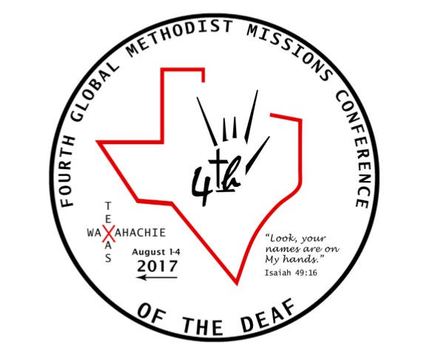

Use the hashtag #4GMDeaf on social media to spread the word!

Text 4GMD to 74483 and your donation will support the 4th Global Methodist

Missions Conference of the Deaf

**Conference Activities**

**Tuesday August 1**

*11:00 AM-6:00 PM Certified Lay Servant Training Cabin 19*

3:00 PM Check in Opens Adams-Mangrum Lodge

3:00-6:00 PM Camp Activities Time Pecan Room and Campground

6:00-7:30 PM Dinner Dining Hall

7:30-9:00 PM Opening Worship Magnolia Room

9:00-10:30 PM Social Time Magnolia Room

9:15-10:30 PM Tractor Rides and Campfire Outside the Adams-Mangrum S’mores Lodge

**Wednesday August 2**

7:30-8:00 AM Morning Devotions Pecan Room

8:00-9:00 AM Breakfast Dining Hall

(*WFDM Executive Officers eat together* )

9:00-10:00 AM Reports from the Nations Magnolia Room

10:00-10:30 AM Break and social time

10:30-12:00 PM Reports from the Nations Magnolia Room

12:00-1:30 PM Lunch Dining Hall

*(UMCD Jurisdictional groups*

*may have lunch together)*

1:30-3:00 PM Workshop: Alzheimer’s and Magnolia Room

Dementia Care

3:00-3:30 PM Break and social time

3:30-5:00 PM Mill Neck Workshop on Best Magnolia Room

Practices for Missions

5:00-6:30 PM Dinner Dining Hall

*(UMC-DHM will eat together)*

*6:00-8:00 PM Certified Lay Servant Training Cabin 19*

6:30-8:00 PM Recreation and free time Pecan Room and Campground

8:00-10:00 PM Cultural Performance Night Magnolia Room

**Thursday August 3**

7:30-8:00 AM Morning Devotions Pecan Room

8:00-9:00 AM Breakfast Dining Hall

*(ELM officers eat together)*

9:00-11:00 AM Listening Panel on Being Magnolia Room

Effective Mission Partners

11:00-12:00 PM Break time Pecan Room and Campground

12:00-1:30 PM Lunch Dining Hall

(*UMCD officers will eat together)*

1:30-2:30 PM Speaker: Caesar Rentie Magnolia Room

2:30-3:00 PM Short break

3:00-4;30 PM Reports from the Nations Magnolia Room

4:30-5:00 PM Free time

5:00-6:30 PM Dinner Dining Hall

*(UMC-DHM will eat together)*

*6:00-8:00 PM Certified Lay Servant Training Cabin 19*

6:30-8:00 PM Recreation and free time Pecan Room and Campsite

8:00-10:00 PM Cultural Performance Night Magnolia Room

**Friday August 4**

7:30-8:00 AM Morning Devotions Pecan Room

8:00-9:00 AM Breakfast Dining Hall

(*WFDM Executive Officers eat together* )

9:00-10:00 AM World Federation of Deaf Pecan Room

Methodist Leaders meeting

*(those not in the meeting can use this time to pack their bags*

*Please be checked out of your rooms by noon!)*

10:00-12:00 PM Closing Worship Magnolia Room

12:00-1:30 PM Lunch Dining Hall

1:30 PM Departures - God be with you until we meet again!

*(see the Post Conference Schedule for optional activities)*

**Campground Activities Schedule**

Enjoy these activities at your leisure and in your free time!

**Monday July 31 Wednesday August 2**

5:00-6:00 PM Outdoor Pool 6:00-8:00 PM Lake Activities

7:30-8:30 PM Gym Activities 6:00-8:00 PM Indoor Pool

**Tuesday August 1 Thursday August 3**

1:00-2:00 PM Lake Activities 6:00-7:00 PM Outdoor Pool

3:00-5:00 PM Sand Volleyball6:00-8:00 PM Indoor Pool

6:00-8:00 PM Lake Activities

**Post Conference Schedule**

**Friday, August 4**

1:00-2:00 PM Depart from Lakeview Camp. Guests needing transport to their

departing flights will be arranged. Guests remaining in the Dallas area after the conference will be given transportation to their pre-arranged lodgings.

5:30-7:30 PM Deaf fellowship and hamburger cookout at Lovers Lane UMC. Shuttle

service is provided for guests staying at the Embassy Suites.

**Saturday, August 5**

8:00 AM Guests meet at Lovers Lane UMC, 9200 Inwood Road, choose one of the following tours: (Allow $40 for two meals out)

1 .The President’s Tour: Visit the George W. Bush Library on the campus of Southern

Methodist University. Oval Office replica and 9/11 exhibits. Lunch at Café 43. Visit the John F. Kennedy museum with dinner and shopping in the West End.

2. Cowboys and Cowboy Tour: Visit the home of the NFL Dallas Cowboys and player locker rooms. See the Fort Worth Stockyard Station, home of real cowboys. Shopping time and a one hour train ride included.

3. Six Flags Over Texas: All day fun of thrilling rides and activities.

9:00 PM Tours return to hotels and lodgings.

**Sunday, August 6**

9:00 AM Deaf worship and Fellowship in Watson Hall, Lovers Lane UMC.

10:50 AM Worship and Holy Communion in the Sanctuary.

12:00 PM Lunch in Watson Hall

1:00 PM Departures for airports and return home

**A Message from Tom**

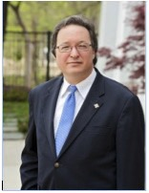

Welcome to our 4th Global Methodist Missions Conference of the Deaf and to Waxahachie, Texas. Thank you for responding to the invitation to be part of this fourth international gathering of Deaf Christians from the Wesleyan family of Methodists, and our connection to all Christians in Christ’s Body, the Church. Our theme is “Look, your names are on My hands,” based on Isaiah 49:16. This verse appeared during the time of Israel’s exile in Babylon, and painful wondering if God had forgotten his chosen people. Through the prophet Isaiah came a stirring response from God, “Can a mother forget her nursing child? Though even if they forget, I will not forget you. See I have engraved you on the palms of My hands.” God claims his people, using the very symbol of a slave’s ownership to one’s master, a tattoo, to declare his bond. May God’s beloved Deaf community see in God’s hands, our names, in the language of signs. May our time together be an offering of praise to God, of gratitude to Christ, and cooperation with the Holy Spirit.

Grace and peace, Rev. Tom Hudspeth, D.Min.,

General Secretary, World Federation of Deaf Methodists, and host pastor, Lovers Lane UMC, Dallas, Texas

**Opening Worship Drums**

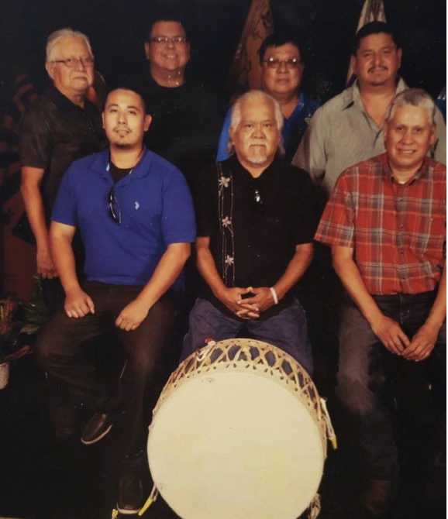

**Numu Tomoyaketu/Comanche Thunder**

is a Southern plains drum group comprised of

brothers who have been together for four years.

Comanche Thunder songs are of the Comanche people, Influenced by an uncle, Elton Yellowfish. We sing to enjoy the Spirit of our people that still remain and the goodness that is among all of us. When we sing and drum we are honoring our ancestors.

Members: Jim Yellowfish, Tim Yellowfish, Tennyson

Yellowfish, Byron Komah, Josh Guererro, and Anthony Nauni

**Master of Ceremonies**

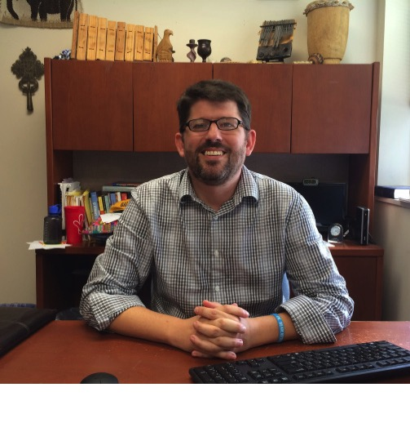

**Rev. Dr. Kirk VanGilder**

Kirk VanGilder, Ph.D., is the associate professor of religion at Gallaudet University in Washington, D.C. Kirk was born hard of hearing before losing more hearing in late adolescence and transitioning into the Deaf world. He is an ordained United Methodist clergy person and has served as a minister in Deaf churches in Baltimore and Pasadena, MD as well as campus minister to Gallaudet University from 1997-2002. Kirk has also traveled to Kenya, Zimbabwe, and Turkey to work with Deaf community development and support.

**Presenters**

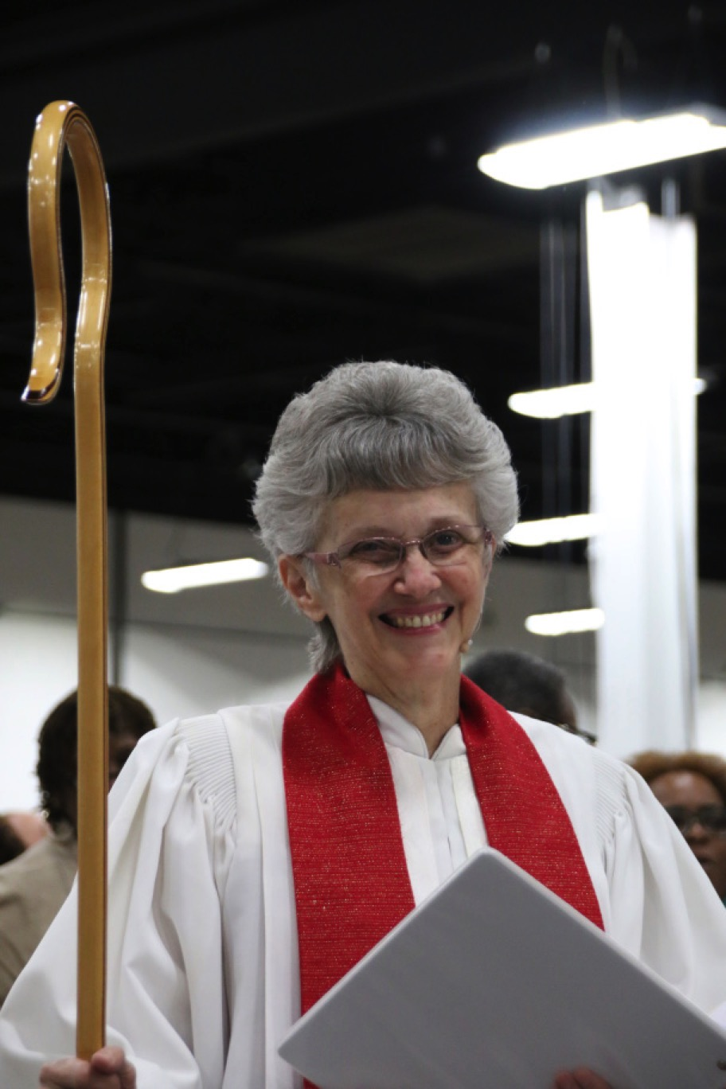

**Bishop Peggy A. Johnson - Opening Worship**

Bishop Peggy A. Johnson is a native of Baltimore,

Maryland and serves as the episcopal leader of the

Philadelphia Area of the United Methodist Church, which includes the Eastern Pennsylvania Annual Conference and the Peninsula-Delaware Annual Conference. She received a Bachelor of Science degree from Lebanon Valley College, a Master of Divinity from Asbury Theological Seminary and a Doctor of Ministry degree from Wesley Theological Seminary. Prior to her election to the episcopacy in 2008 she served as a pastor in the Baltimore-Washington

Conference since 1980. Her churches included a 4-point rural circuit in Frederick, MD, a suburban Baltimore congregation, a campus ministry at Gallaudet University and for 20 years she was the pastor of the Christ UMC of the Deaf. Bishop Johnson has a particular passion for ministry with people with disabilities and her years as the pastor of an all-Deaf congregation led her on paths of experience with not only the deaf and deaf-blind communities but also with those who have mobility, intellectual, and mental health challenges. She is married to the Rev. Michael C. Johnson, a United Methodist pastor, and they have two adult sons, Peter and Gabriel.

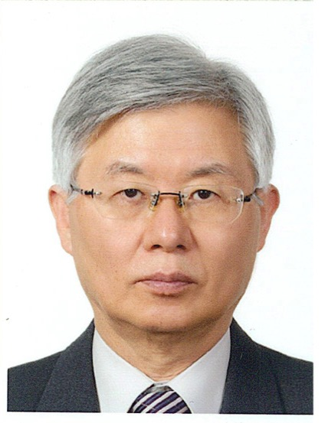

**Rev. Joo Hai Kang - Morning Devotions**

Rev. Joo Hai Kang was born in Korea and became Deaf at the age of 2. He entered and graduated from Seoul National School for the Deaf before entering and graduating from the

Presbyterian Theological Seminary in Seoul, Korea. Rev. Kang later studied and graduated from Wesley Theological Seminary in Washington, DC, USA. He was ordained as the first Deaf Presbyterian minister in Korea and served Youngnak

Presbyterian Church of the Deaf in Seoul, Korea as an assistant pastor and later as senior pastor. In the USA, he has served Jacksonville Methodist Church of the Deaf in Jacksonville, IL and Magothy Methodist Church of the Deaf in Pasadena, Maryland. Rev. Kang is currently serving the Lord’s Grace Deaf Mission Church in Seoul, Korea. He has also been on the boards for the World Federation of the Deaf and Korean Association of the Deaf. He was also elected president of the Society of the Korean Sign Language Studies.

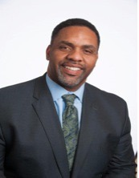

**Rev. Caesar Rentie - Thursday Afternoon Speaker**

Rev. Rentie is the Chaplain Vice President of Pastoral Services for Methodist Health System and also a Licensed Local Pastor for North Texas Conference of the United Methodist Church. Caesar served as Sr. Pastor for Acadia Park United Methodist 2003-2011. He is currently on staff at First United Methodist Mansfield. He earned a BA from the University of Oklahoma in 1988; he majored in Communications, where he also played football for Barry Switzer and the Oklahoma Sooners. He

attended Texas Christian University in 1997, Brite Divinity School where he

received his Master of Theological Studies. In his former career he played

professional football in the NFL and in the World League of American football.

During that time he played for the Chicago Bears, the New York New Jersey Knights, and the Birmingham Fire. He is an adult child of Deaf parents and husband to his lovely wife of five years Cynthia Rentie and the parent to three children

Dennis, Carra and Chloe.

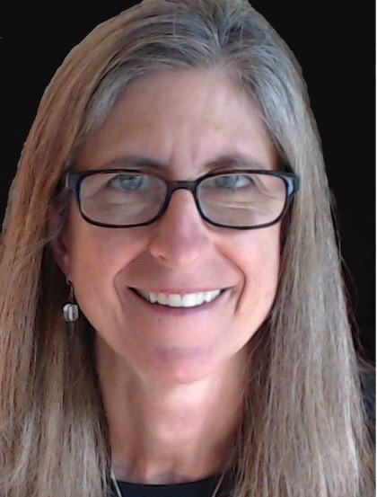

**Dr. Amy T. Wilson - Mill Neck International**

Amy T. Wilson is Director of International Programs at the Mill Neck Family of Organizations, where she leads a team of

specialists who share their expertise, knowledge, and technical skills with parents, educators, and professionals in economically poor countries. Dr. Wilson was a professor in the Department of Educational Foundations and Research at Gallaudet University for 14 years. After living in developing countries and noting the poor assistance people with disabilities were receiving from U.S.

development organizations, she developed Gallaudet’s MA degree in International Development. The degree, which is the only one of its kind in the United States, focuses on the inclusion of people with disabilities in development

assistance programs and in nongovernmental, federal, and faith-based development organizations both in the United States and overseas. Dr. Wilson evaluates and advises development organizations and agencies (e.g., U.S. Agency for International Development, the InterAmerican Development Bank, the World Bank, and the Peace Corps) about the inclusiveness of their programs, as well as their effectiveness with various disability communities.)

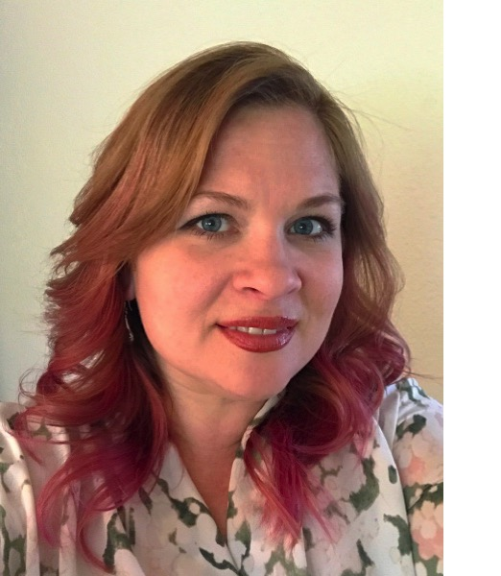

**Sarah Houge - Mill Neck International**

Sarah Houge graduated from the University of Minnesota with a bachelor’s degree in English and Masters of Education in Special (Deaf) Education. Inspired by her experience as a Peace Corps volunteer in Jamaica, Sarah was driven to learn about the field of international development and enrolled in the International

Development for People with Disabilities M.A. (IDMA) program at Gallaudet University. Upon graduation in 2010, she worked with the World Federation of the Deaf on their Human Rights and Capacity Building Project in the West and Central African region. Sarah has collaborated with grassroots organizations including Global Deaf Connection, focusing on Deaf Education and mentoring in Kenya, and Global Reach Out with youth exchange programs in India. She participated in exchange programs through Mobility International USA in Jordan, working to improve conditions for women and girls with disabilities, as well as Discovering Deaf Worlds’ EMPOWER Program in the Philippines sponsored by the U.S. Department of State. Sarah also completed a consultancy for UNICEF in Bhutan, where she compiled the first

research report on the Deaf community in the history of the nation.

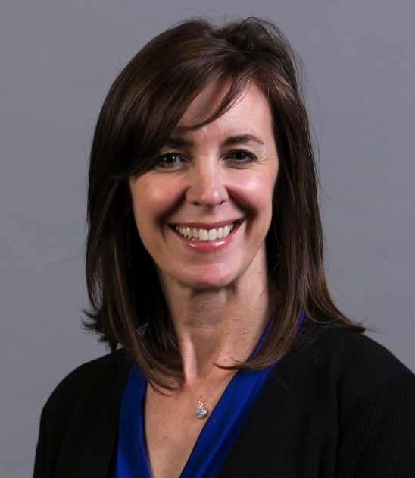

**Kathy Shockley - Alzheimer’s Association, Greater Dallas Chapter**

Kathy Shockley joined the Alzheimer’s Association Greater Dallas Chapter in October, 2016, as Field Manager, Programs & Services. Kathy is a licensed nursing home

administrator in the state of Texas, with a Masters in Long Term Care from the University of North Texas. She has worked in the field of long term care in Dallas since 1994, with a primary focus on dementia care. Kathy has been an active volunteer with the Dallas Independent School

District since 2003, and she currently serves as President of the National Charity League Dallas Chapter. Kathy and her husband Bryan have been married 22 years, and have 2 daughters, Carlyn and Anna. Their favorite family pastimes involve Rangers games and traveling to

Northwest Michigan each summer. Kathy and Bryan are also members of Lovers Lane United Methodist Church.

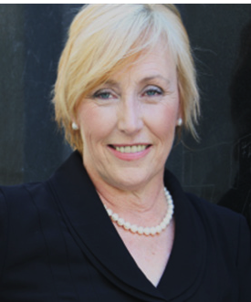

**Debra Adams - Alzheimer’s Association, Greater Dallas Chapter**

Debra Adams currently serves as the Director, Community Relations. With a Master’s in Organizational Leadership, Non-profit Management Certification and Bachelors of Religious Education, Debra has held senior leadership

positions in education or healthcare related non-profit settings for over 30 years. Debra’s expertise is to fulfill the mission of an organization expanding revenue, outreach and program development by maximizing the experience and expertise of both a staff and volunteer workforce. Prior to joining the Alzheimer’s Association 6 years ago, Debra was Vice President of Programs and Services for Junior Blind of America, Los Angeles, California responsible for 14 programs and over 200 staff. Debra has also served as Regional Manager for ResCare, Inc., and held staff positions as Director of Education Services at three faith-based organizations. Debra and her husband have been married for 35 years with three adult children and three loving grandsons with whom she spends much of her free time. Debra and her husband are the founders of Adams Family Ministries, published authors and public speakers with a focus on marriage and family success.

**Many thanks to our contributors!**

*John Wesley Level:*

Anonymous Donor

*Susanna Wesley Level:*

Rosie Royals, in honor of Deaf youth

Kay Olmstead, in honor of Korean Deaf Ministry

*Rev. Philip Hasenstab Level:*

Rev. Dr. Kirk VanGilder in memory of his mother, Jane VanGilder

*Laurent Clerc Level:*

Marie Guard

*Rev. Thomas Gallaudet Level:*

Tom & Penny Posedly, in memory of Rev. Diana Williams

Michelle Menefee, in memory of Rev. Wineva Hankamer

Mary Kay Hudspeth

Anonymous Donor

*Additional contributions:*

Rebecca Dunning, in memory of her father, Dale Dunning

Stephanie Blakey, in honor of our international guests

A special thank you to the many volunteers from Lovers Lane United

Methodist Church who have given their time and resources to making our

conference possible!

And a very special thank you to all the interpreters from around the world who have donated their time and expertise to assist in facilitating between the many languages of our conference.

And thank you to the Korean Central UMC of Irving, TX for transportation and hospitality for our Korean visitors and Christ Foundry United Methodist Mission, Dallas, TX for

loaning the use of their van.

**Save the date! July 22-29, 2018**

UMCD and UMC-DHM will join the:

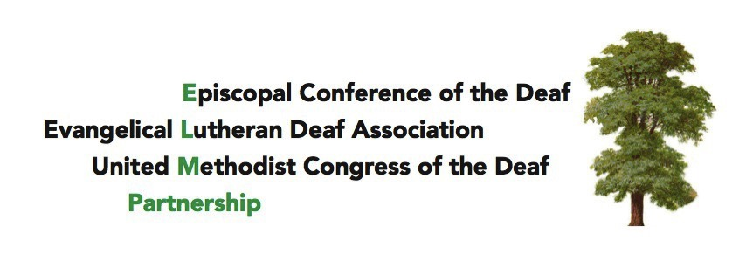

in Las Vegas, NV for our national meetings!

See the flyer at umcd.org for more details.

**Sponsors**

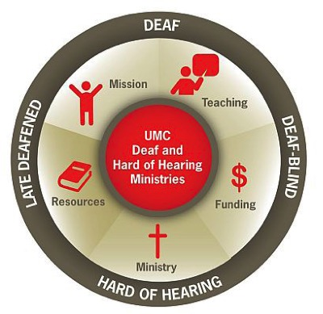

United Methodist Committee on Deaf and Hard of Hearing Ministries

<https://www.umdeaf.org>

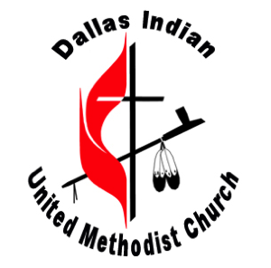

Dallas Indian United Methodist Church

<http://www.dallasindianumc.org>

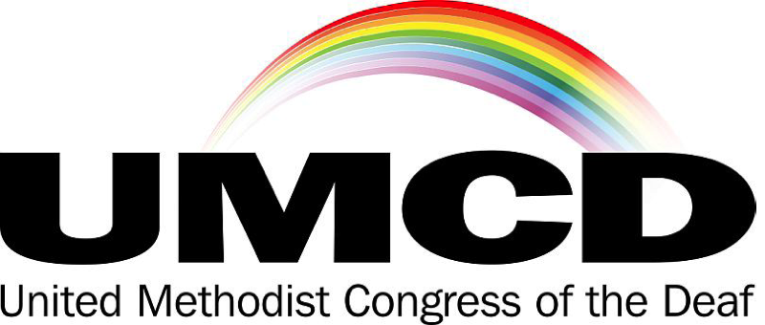

https://www.umcd.org

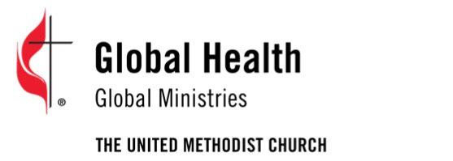

http://www.umcmission.org/Explore-Our-Work/global-health



Lovers Lane UMC Deaf Ministry

<http://llumc.org/deafministry>



Mill Neck International

https://millneck.org



http://deafbiblesociety.com/